Best Chapter Retreat: South Africa
2026 Dates to be announced shortly!
Welcome, thank you for your interest in joining this exclusive career transformation retreat in the heart of the African wild.

Please drop us a line at retreats@betschapter.live, and we will be in touch with you.

Warm regards,
Gyongy
Gyongyver SZABO

LinkedIn
www.bestchapter.live

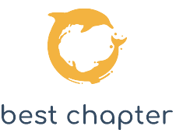
talent ∙ purpose ∙ career

